S. Sharafat and N. M. Ghoniem

University of California at Los Angeles (UCLA)
Los Angeles, CA. 90095-1597, USA

APEX Electronic-Meeting

UCLA

August 24, 2000
Summary of Thermo-Physical Properties of:
Sn and Compounds of Sn
Comparison of Properties of Sn, Sn-Li, Li,
and Pb-Li

Recently Published Reports on Sn-Li Coolants
2
- Properties are summarized in:
S. Sharafat, N. Ghoniem, “Summary of Thermo-Physical Properties of Sn, and Compounds of Sn-H, Sn-O, Sn-C, Sn-Li, and Sn-Si,” UCLA Report, UCLA-UCMEP-00-31, Aug. 2000.

- Thermodynamic assessment of the stability of ceramic materials in Sn-Li is available:
S. Sharafat, N. Ghoniem, “Thermodynamic Stability Assessment of Oxides, Nitrides, and Carbides in Liquid Sn-25Li,” UCLA Report, UCLA-UCMEP-00-32, Aug. 2000.

- Both reports are currently posted on the APEX web site (www.fusion.ucla.edu/APEX/)
Table of Contents of Property
Report

Table of Tables 5
Table of Figures 5
1. Thermo-Physical Properties of Sn 7
1. 1 Physical Properties of Metallic Tin 7
1. 2 Specific Volume of Sn 10
1. 3 Density of Sn 11
1. 4 Volumetric expansion coefficient (γ) of liquid Sn: 12
1. 5 Compressibility of Sn 12
1. 6 Viscosity of liquid Sn 13
1. 7 Thermal Conductivity of Liquid Sn: 14
1. 8 Surface Tension of Sn: 15
1. 9 Vapor Pressure of Sn 16
1. 10 Boiling Point of Sn 17
1. 11 Heat of Sublimation (L_{s}) and Vaporization (L_{v}): 18
1. 12 Critical Pressure (p_{c}), Temperature (T_{c}), and Volume (V_{c}) 18
1. 13 Heat Capacity of Sn 18
1. 14 Electrical Resistivity (ρ) of liquid Sn 19

2. Thermodynamic Properties of Sn 20
2. 1 Enthalpy, Specific Heat, and Entropy of Sn-Vapor 20
2. 2 Heat of Dissociation, Reaction Enthalpy, and Ionization Potentials of Various Tin-Compounds 21
2. 3 Thermodynamic data of Sn-Silicates 24
2. 3. 1 Specific heat (c_{p}) of Sn-Silicates as a function of temperature 24
2. 4 The Sn-H System 24
2. 4. 1 Absorption of Hydrogen 25
2. 4. 2 H₂-Adsorption 25
2. 4. 3 H₂-Diffusion Coefficient 26
2. 4. 4 Reduction of Sn by atomic hydrogen 26
2. 4. 5 The SnH and SnD Molecule 26
2. 4. 6 Solubility of the gas composition H₂-CO-CO₂ 26
2. 5 The Sn-Li System 27
Stability of Li₂SnO₃* 27
2. 6 The Sn-C System 27
2. 6. 1 Solubility 27
2. 6. 2 The Sn-C Molecule 28

2. 6. 3 The SnCO₃ Molecule 28
2. 7 The Sn-Si System 29
2. 7. 1 Diffusion of Sn in Solid Si and Si in Liquid Sn 29
2. 7. 2 The Sn-Si Molecule 30
2. 8 Sn and Oxygen 30
2. 8. 1 Low Pressure Oxidation 30
2. 8. 2 Oxidation Mechanism: 30
2. 8. 3 Solubility of Oxygen in Liquid Sn 31
2. 9 The SnO-SiO₂ System 32
2. 10 General Literature on Corrosion of Sn with Metals: 32

3. Comparison of Thermo-Physical Properties between Sn, Li, and Pb-Li 33
3. 1 Thermal Conductivity 33
3. 2 Electrical Resistivity 34
3. 3 Surface Tension 35
3. 4 Dynamic Viscosity 36
3. 5 Vapor Pressure 37
3. 6 Density 38

4. Chemical Compatibility of Ceramic Materials with Sn-Li 39

5. Publications on Liquid Metal - Structural and Insulating Materials Interaction (1994 - 1999) 41
5. 1 Publications Relating to Corrosion: 41
5. 2 Publications Relating to Erosion: 47
5. 3 Selected Titles on Corrosion and Erosion: 48

3
Table of Contents of Property
Report (cont.)

2. 6. 3 The SnCO3 Molecule PAGEREF _Toc491342905 \h
28
2. 7 The Sn-Si System PAGEREF _Toc491342906 \h
29
2. 7. 1 Diffusion of Sn in Solid Si and Si in Liquid Sn PAGEREF _Toc491342907 \h
29
2. 7. 2 The Sn-Si Molecule PAGEREF _Toc491342908 \h
30
2. 8 Sn and Oxygen PAGEREF _Toc491342909 \h
30
2. 8. 1 Low Pressure Oxidation PAGEREF _Toc491342910 \h
30
2. 8. 2 Oxidation Mechanism: PAGEREF _Toc491342911 \h
30
2. 8. 3 Solubility of Oxygen in Liquid Sn PAGEREF _Toc491342912 \h
31
2. 9 The SnO-SiO2 System PAGEREF _Toc491342913 \h
32
2. 10 General Literature on Corrosion of Sn with Metals: PAGEREF _Toc491342914 \h
32

3. Comparison of Thermo-Physical Properties between Sn, Li, and Pb-Li PAGEREF _Toc491342915 \h
33
3. 1 Thermal Conductivity PAGEREF _Toc491342916 \h
33
3. 2 Electrical Resistivity PAGEREF _Toc491342917 \h
34
3. 3 Surface Tension PAGEREF _Toc491342918 \h
35
3. 4 Dynamic Viscosity PAGEREF _Toc491342919 \h
36
3. 5 Vapor Pressure PAGEREF _Toc491342920 \h
37
3. 6 Density PAGEREF _Toc491342921 \h
38

4. Chemical Compatibility of Ceramic Materials with Sn-Li PAGEREF _Toc491342922 \h
39

5. Publications on Liquid Metal - Structural and Insulating Materials Interaction (1994 - 1999) PAGEREF _Toc491342923 \h
41
5. 1 Publications Relating to Corrosion: PAGEREF _Toc491342924 \h
41
5. 2 Publications Relating to Erosion: PAGEREF _Toc491342925 \h
47

5. 3 Selected Titles on Corrosion and Erosion:……………………………………. PAGEREF _Toc491342926 \h
48
4
CLICK TO EDIT MASTER TITLE STYLE
Table of Tables
HYPERLINK \l "_Toc491344311"
Table 1: Stable and Unstable Isotopes of Tin [1] PAGEREF _Toc491344311 \h
7
Table 2: Physical Properties of Tin [1] PAGEREF _Toc491344312 \h
8
Table 3: Thermal Data of Tin [1] PAGEREF _Toc491344313 \h
9
Table 4: Thermodynamic Values of Sn-Vapor PAGEREF _Toc491344314 \h
20
Table 5: Heat of Dissociation of Sn-Compounds PAGEREF _Toc491344315 \h
21
Table 6: Reaction Enthalpies of Sn-Compounds PAGEREF _Toc491344316 \h
22
Table 7: Ionization Potentials of Sn-Compounds PAGEREF _Toc491344317 \h
23
Table 8: Thermodynamic Data for Sn-Silicates PAGEREF _Toc491344318 \h
24
Table 9: Hydrogen Solubility. PAGEREF _Toc491344319 \h
24
Table 10: Formation Temperature and Stability of Li2SnO3* PAGEREF _Toc491344320 \h
27
Table of Figures
HYPERLINK \l "_Toc491319146"
Figure 1: Specific volume of liquid Sn as a function of temperature (after Doge [2]). PAGEREF _Toc491319146 \h
10
Figure 2: Density of liquid Sn as a function of temperature. PAGEREF _Toc491319147 \h
11
Figure 3: Dynamic Viscosity of liquid Sn as a function of temperature. PAGEREF _Toc491319148 \h
13
Figure 4: Thermal conductivity of liquid Sn as a function of temperature PAGEREF _Toc491319149 \h
14
Figure 5: Surface tension of liquid Sn. PAGEREF _Toc491319150 \h
15
Figure 6: Vapor pressure of Sn as a function of temperature. PAGEREF _Toc491319151 \h
17
Figure 7: Electrical resistivity of liquid Sn as a function of temperature. PAGEREF _Toc491319152 \h
19
Figure 8: Comparison of thermal conductivity of liquid Sn, Li, Pb-17Li, and Sn-25Li. PAGEREF _Toc491319153 \h
33
Figure 9: Electrical resistivity of liquid Sn, Pb-17Li, and Li. PAGEREF _Toc491319154 \h
34
Figure 10: Comparison of surface tension of liquid coolants PAGEREF _Toc491319155 \h
35
Figure 11: Comparison of the dynamic viscosity of liquid coolants. PAGEREF _Toc491319156 \h
36
Figure 12: Comparison of the vapor pressure of liquid coolants. PAGEREF _Toc491319157 \h
37
Figure 13: Comparison of the density of liquid coolants. PAGEREF _Toc491319158 \h
38
Figure 14: Calculated stability of various nitrides, carbides and oxides in liquid Sn-25Li at 773K. PAGEREF _Toc491319159 \h
40

5
COMPARISON OF COOLANT PROPERTIES

Thermal Conductivity

References:
B. Schulz, Fusion Eng. Design 14 (1991) 199.
R. W. Ohse (Ed.) Handbook of Thermodynamic and Transport Properties of Alkali metlas, Inter. Union of Pure and Applied Chemistry Chemical Data Series No. 30. Oxford: Blackwell Scientific Publ., 1985, pp. 987.
Ya. I. Dutchak, V. P. Osipenko, P. V. Panasyuk, Izv, Vyssh. Zavedenii, Fiz, 1968, No. 10, p. 154/C, C.A. 70[1969] No. 61918.
6
COMPARISON OF ELECTRICAL RESISTIVITY

Electrical Resistivity

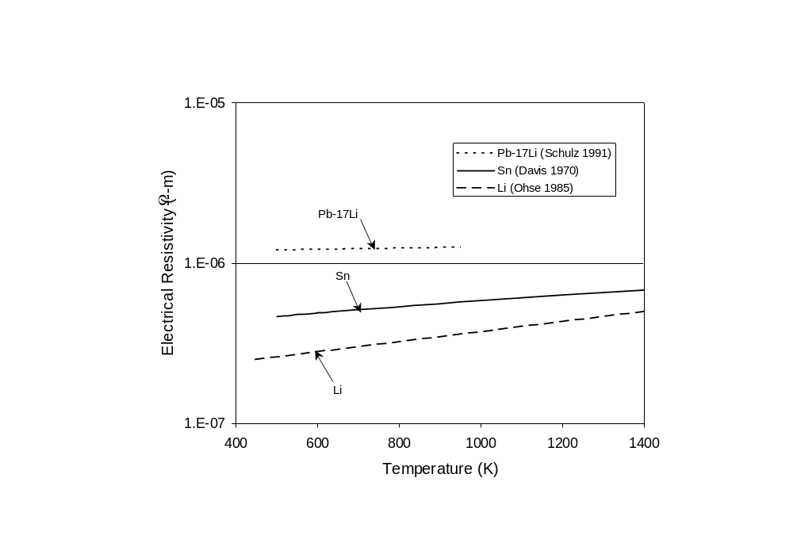

References:
B. Schulz, Fusion Eng. Design 14 (1991) 199.
H. A. Davis, J. S. L. Leach, Phys. Chem. Liquids 2 (1970) 1/12, 5.
R. W. Ohse (Ed.) Handbook of Thermodynamic and Transport Properties of Alkali metlas, Inter. Union of Pure and Applied Chemistry Chemical Data Series No. 30. Oxford: Blackwell Scientific Publ., 1985, pp. 987.
7
COMPARISON OF SURFACE TENSION
Surface Tension

References:
L.L. Bircumshaw, Phyl. Mag. 17 No. 7 (1934) 181/91, 186.

B. Schulz, Fusion Eng. Design 14 (1991) 199.

R. W. Ohse (Ed.) Handbook of Thermodynamic and Transport Properties of Alkali metlas, Inter. Union of Pure and Applied Chemistry Chemical Data Series No. 30. Oxford: Blackwell Scientific Publ., 1985, pp. 987
8
COMPARISON OF DYNAMIC VISCOSITY

Dynamic Viscosity

References:
B. Schulz, Fusion Eng. Design 14 (1991) 199.
R. W. Ohse (Ed.) Handbook of Thermodynamic and Transport Properties of Alkali metlas, Inter. Union of Pure and Applied Chemistry Chemical Data Series No. 30. Oxford: Blackwell Scientific Publ., 1985, pp. 987.
E. Rothwell, J. Inst. Metals 90 (1962) 38/94, 392.

9
COMPARISON OF VAPOR PRESSURE

Vapor Pressure

References:
K. K. Kelly, U.S. Bur. Mines Bull. Nr. 383 (1935) 1/132, 105.

M. Abdou, et al., “On the Exploration of Innovative Concepts for Fusion Chamber Technology: APEX Interim Report,” University of California School of Engineering and Applied Science, UCLA-ENG-99-206, Nov. 1999.

M. Abdou, et al., “ Blanket Comparison and Selection Study Final Report,” Argonne National Laboratory Report, ANL/FPP-84-1, Vol. 2.,1984.

10
COMPARISON OF DENSITY

Density

References:
B. Schulz, Fusion Eng. Design 14 (1991) 199.

R. W. Ohse (Ed.) Handbook of Thermodynamic and Transport Properties of Alkali metlas, Inter. Union of Pure and Applied Chemistry Chemical Data Series No. 30. Oxford: Blackwell Scientific Publ., 1985, pp. 987.

B. B. Alchagirov, A. M. Chochaeva, “Temperature dependence of the density of liquid tin,” High Temperature 38: (1) 44-48, JAN-FEB 2000.

11

Temperature Composition Limits For Stable Lithium Salt Formation

12
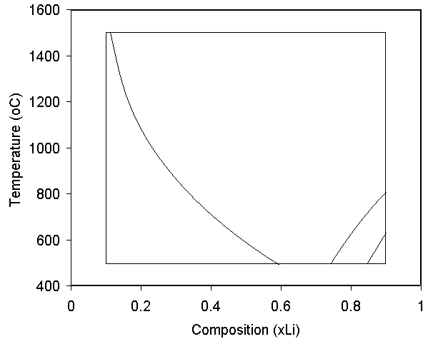
Li₂C₂
Li₃N
LiH
positive
activity
25 at.% Li
negative
activity

Limit of formation (ln a_{i} = 0; i = C, N, or H) of Li₂C₂, Li₃N, and LiH in Sn-Li from Figs. 9, 11, and 13; the corresponding activities are positive to the left of the curves, which indicates dissolution of salts.
13
Thermodynamic Assessment of Ceramic Stability in Sn-25Li

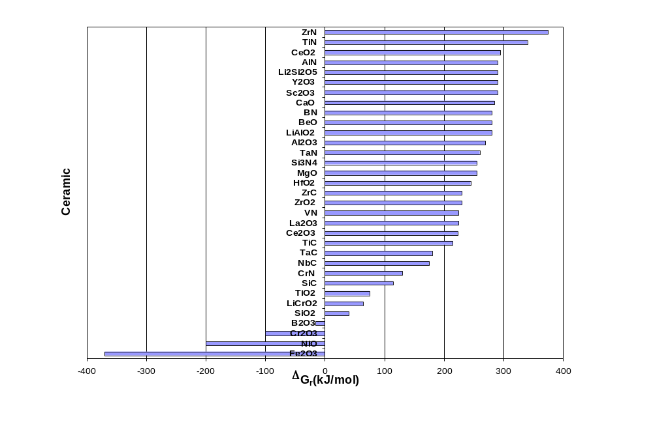

Estimated Δ_{r}G of selected ceramic materials in solute (O, N, C) saturated liquid Sn-25Li at 773°K.
Summary of Ceramic Sn-Li Thermodynamic Compatibility Results

The most stable ceramics are nitrides, followed by oxides, and then carbides.

–Nitrides:
- At 500°C all of the considered nitrides are stable.
- ZrN is the most stable nitride.

–Oxides:
- The most stable oxides are: Sc₂O₃ and Y₂O₃
- Fe2O3, NiO, and Cr2O3 decompose.
- All other considered oxides were found to be stable.
- TiO2 SiO2 marginally stable.
- B2O3 is unstable at Li-fractions above 0.2.

–Carbides
- All carbides including SiC were found to be stable (note: β-SiC is unstable in pure Li).
- ZrC is the most stable carbide.

15

